Tweet Perth Website Notes

Hey mate please see below changes as follows

**Index**

With the feature blog post that show at the top of the page can we make sure that the images aren't resized to fit the feature image area otherwise the image ratio changes and makes the image look out of proportion. Can we have it so the image is resized to the width of the feature image area and then centred. The areas that are then outside of that feature image size are then hidden. ie below I have create photo with same size of feature image. The areas in red would be the parts of the image that are hidden using CSS.

Current Feature Image

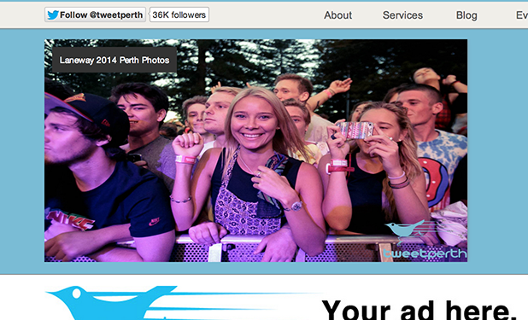

Resize to width and maintain image ratio

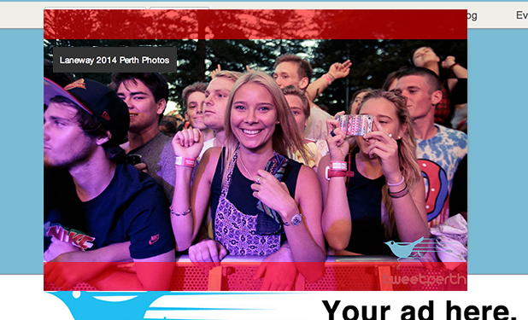

Result would then be the following - See how image is no longer out of ratio

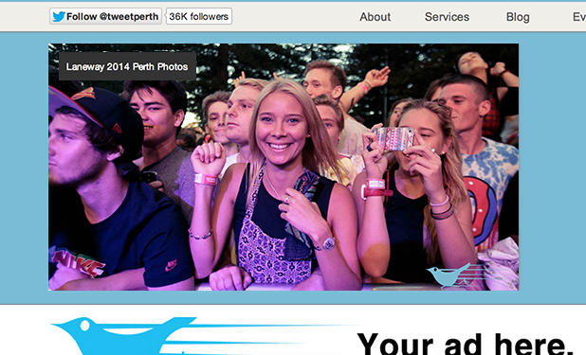

**Blog Single**

As example - [http://tweetperth.com.au/new/wordpress/laneway-2014-perth-photos/](http://tweetperth.com.au/new/wordpress/laneway-2014-perth-photos/" \t "_blank)

Can we make it so if an image is added that is wider than the space provided can it then be resized automatically to fit within the content area and make sure that the image then maintains the correct ratio. As you can see on the current link above you can only see half of the images

**Events Single**

Twitter Feed

Is there a section that allows me to add a custom Twitter widget that would then be specific to that event? ie for example I would need to be able to add the following type of code including the STYLE section within one of the custom field below to go in the designated Twitter feed area as seen on [http://www.tweetperth.com.au/new/events\_sub\_twitter.php](http://www.tweetperth.com.au/new/events_sub_twitter.php" \t "_blank). If there is no Twitter feed, Twitter handle/url however I would like for these not to show as seen on [http://www.tweetperth.com.au/new/events\_sub.php](http://www.tweetperth.com.au/new/events_sub.php" \t "_blank)

Twitter code sample

<style type="text/css">

#twitter-widget-2{width:728px; position: relative; top: -58px; z-index:5; overflow:hidden;}

</style>

<a class="twitter-timeline" href="[https://twitter.com/search?q=from%3AFutureOfficial+OR+%23FutureMusic+OR+%40FutureOfficial](https://twitter.com/search?q=from%3AFutureOfficial+OR+%23FutureMusic+OR+%40FutureOfficial" \t "_blank)" data-widget-id="416771361986465792">Tweets about "from:FutureOfficial OR #FutureMusic OR @FutureOfficial"</a>

<script>!function(d,s,id){var js,fjs=d.getElementsByTagName(s)[0],p=/^http:/.test(d.location)?'http':'https';if(!d.getElementById(id)){js=d.createElement(s);[js.id](http://js.id/" \t "_blank)=id;js.src=p+"://[platform.twitter.com/widgets.js](http://platform.twitter.com/widgets.js" \t "_blank)";fjs.parentNode.insertBefore(js,fjs);}}(document,"script","twitter-wjs");</script>

Twitter Follow Button

Also there needs to be a section where I can add the following code to create the Twitter follow button for the events that want to feature their Twitter account etc as seen on [http://www.tweetperth.com.au/new/events\_sub\_twitter.php](http://www.tweetperth.com.au/new/events_sub_twitter.php" \t "_blank). This would also need to be a custom field area, if there is nothing added to this area then the Twitter follow button is not shown.

Twitter code sample

<a href="[http://twitter.com/FutureOfficial](http://twitter.com/FutureOfficial" \t "_blank)" class="twitter-follow-button">Follow @FutureOfficial</a>

<script src="[http://platform.twitter.com/widgets.js](http://platform.twitter.com/widgets.js" \t "_blank)" type="text/javascript"></script></a>

Banner Images

Can I also have a section within the event single page that will allow me to add an the following

Event page banner image



ie be able to change the image in the background at the top of the page, if one isn't uploaded then the current image is shown as default image. Also can this feature be implemented on the blog single and win single pages aswell.

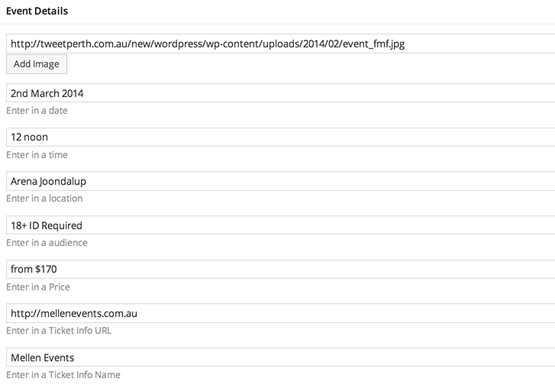

Event Banner

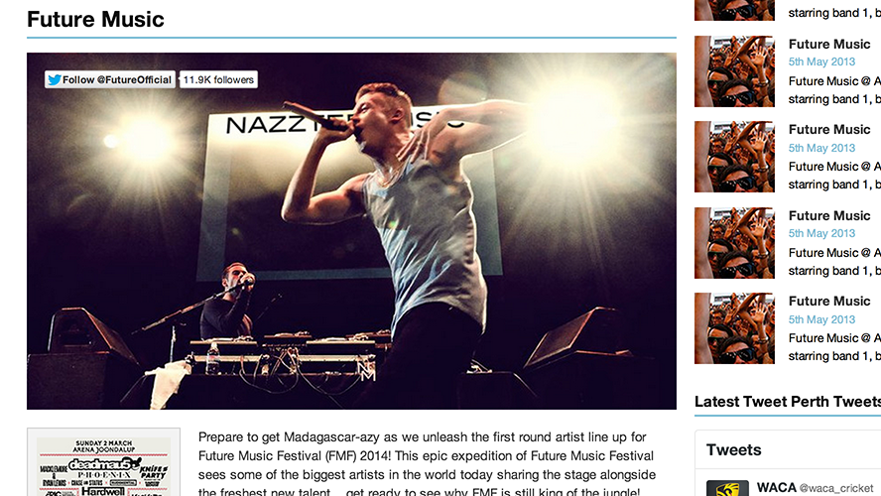

Be able to upload event banner for the event. If one isn't uploaded then there will be no image shown

Event Banner image as seen - <http://tweetperth.com.au/new/events_sub_twitter.php>

No event banner image - <http://tweetperth.com.au/new/events_sub.php>